Linda Monga 2025/03/14

MYP 5 Digital design brief

Grade:10

Project:Making a personal website using CSS & HTML

CRITERION A—Inquiring and Analyzing

In a world where everything is done online, on screens, and through the use of the internet, it is important to adapt to the change, and having an online presence is essential when it comes to communication. People today connect with each other using apps and other digital tools, such as personal websites and portfolios. These platforms help people showcase skills, talents, and accomplishments but also create opportunities to establish meaningful professional and personal relationships. An online portfolio acts as a bridge that helps individuals express their identity; in my case, I will be using a personal website to showcase and put into application what I've learnt over the past months. I will be creating a personal website talking about myself, my skills and accomplishments; I will be creating this personal website using HTML & CSS.

A personal website is an individual’s online platform where they can showcase their skills, achievements, interests, or even their personal story. It serves as a digital portfolio, résumé, or blog, depending on its purpose. People use personal websites to highlight their professional work, share creative projects, connect with others, or express their passions for their interest,allowing them to edit it to reflect their unique identity and goals, whether for professional networking, or personal usage.

HTML-hypertext markup language is a standard language used to create a structured web page,it helps developers define elements such as text,image,links,tables,etc

CSS -Cascading Style Sheets,is a computer language used to style and enhance the appearance of a web page created with html,it helps developer control the layout,color,font,spacing,and the overall behavior of the elements,it makes websites visually appealing and user-friendly, transforming plain HTML into a attractive designs.

The audience for my personal website ranges from my teachers, classmates, future college application process, employers, friends and family members.

CRITERION B - Developing Ideas

The website will have 4 webpages.

It will be

Responsive: The website adapts to different screen sizes (desktop, tablet, mobile) and is user-friendly.

Image: There will be at least 3-4 high-quality images to showcase my work.

Colour: The colours, fonts, and styles will be uniform; the text will be easily readable.

Effective Layout: Use whitespace to create a clean look.

The first page will be a welcome page that briefly tells the user about the content of the website; the second page will display personal information, works and projects with a small description of each; and the third page will contain all forms of communication.Something like this

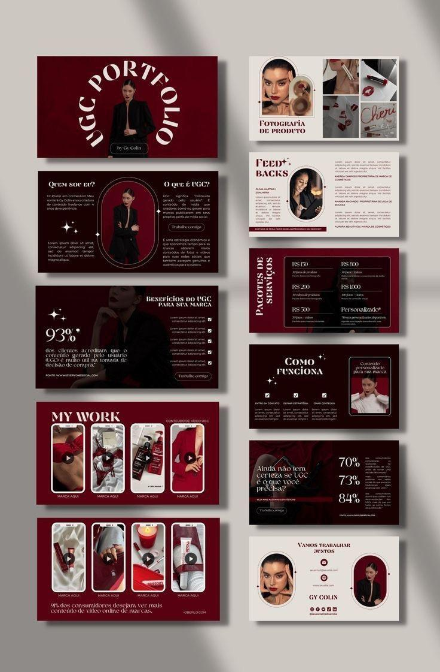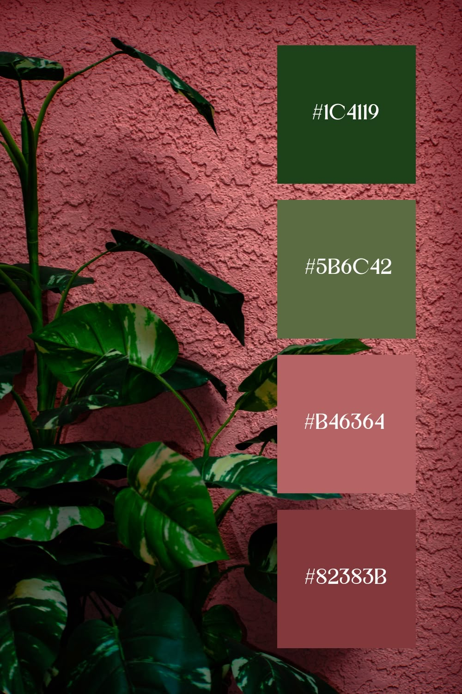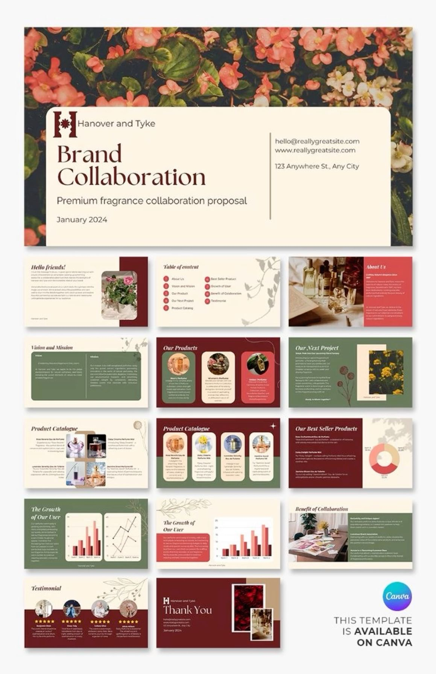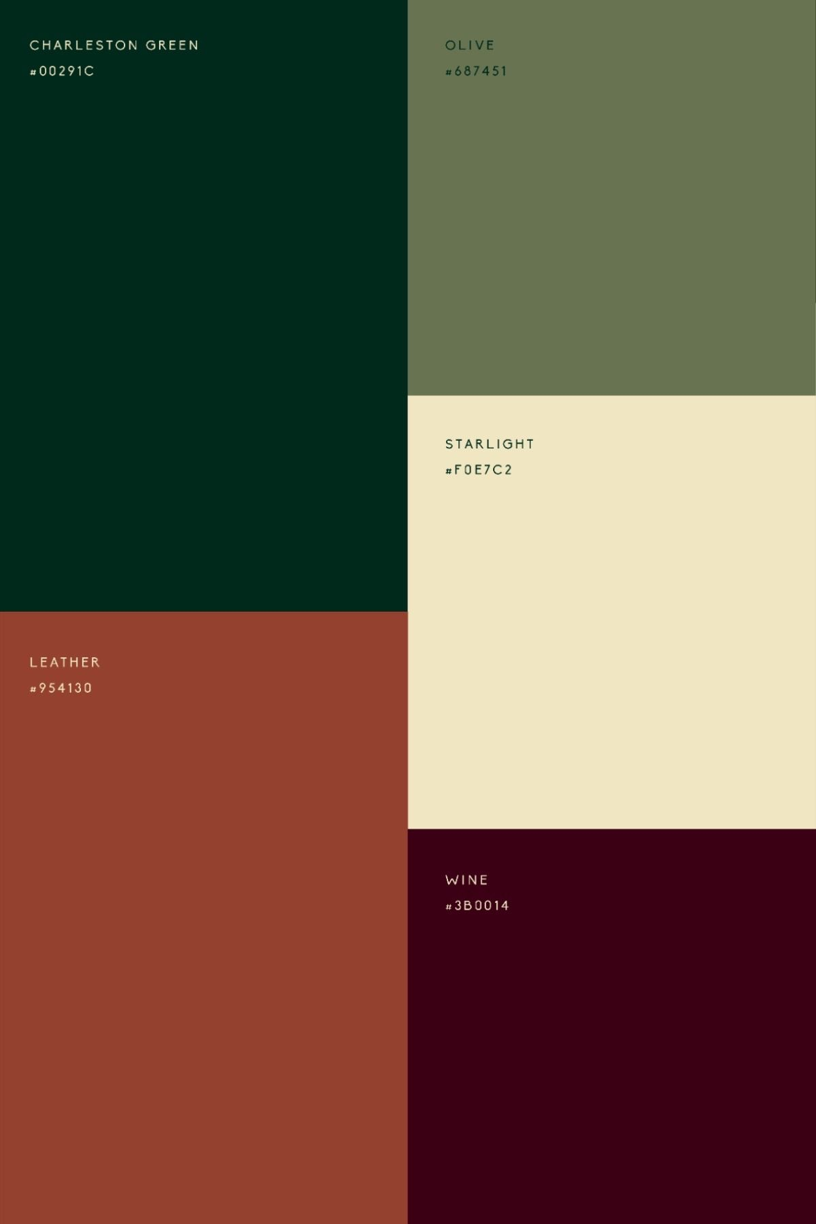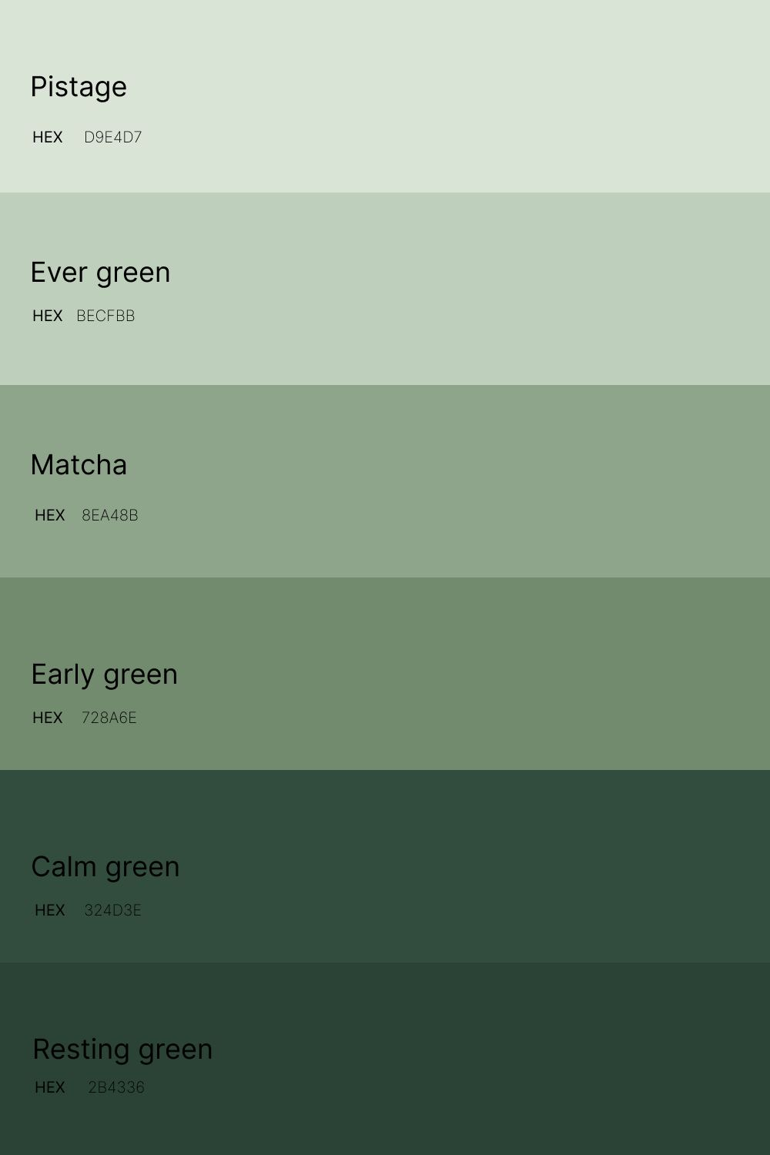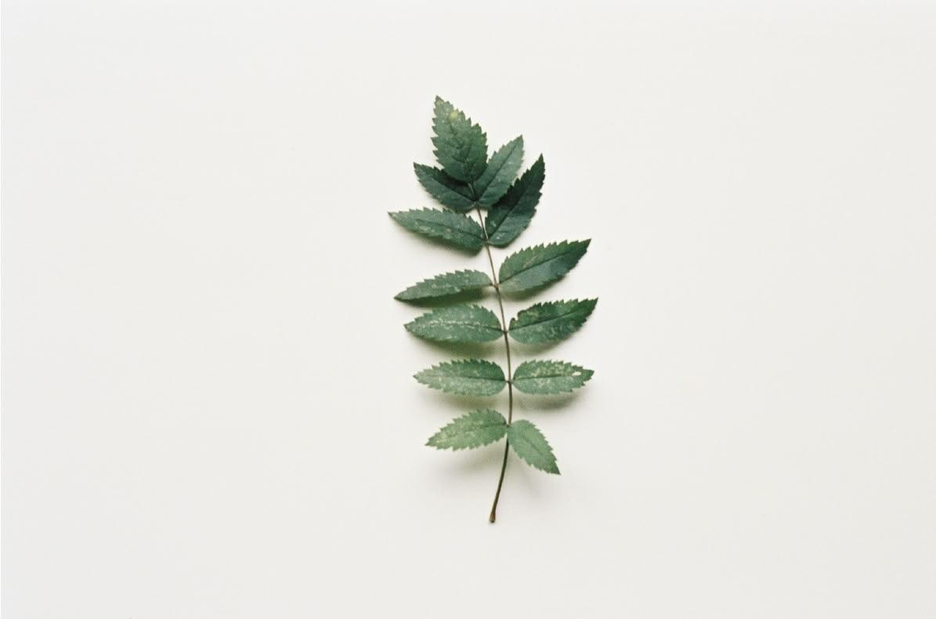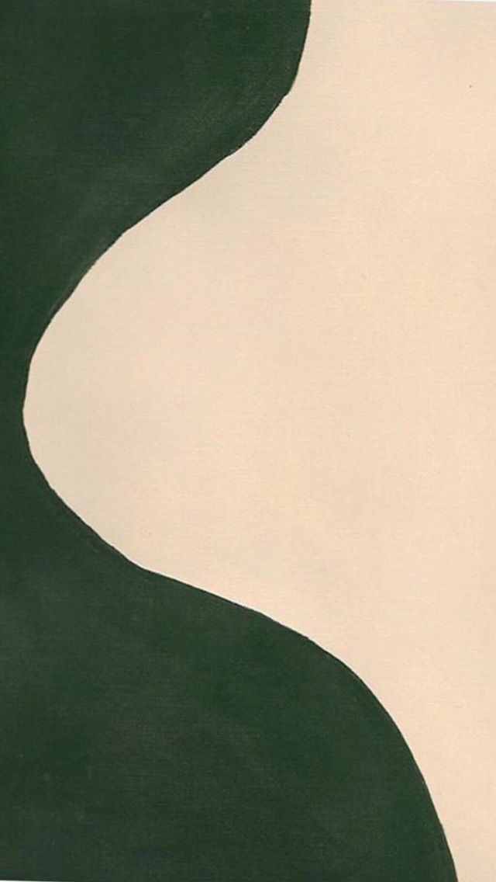

These templates best represent my idea for the website layout and the way the Information will be displayed and the color I will use. I decided to choose these template images because they meet the general criteria of the website, which focuses on facilitating visibility and accessibility but also allows for creativity. The design makes the website accessible on multiple platforms by being able to adapt to the screen size. Simplicity is key; the straightforward layout allows the audience to not get overwhelmed when visiting the website. The theme I'm aiming for is soft and modern, as it not only meets the criteria but also ensures a user-friendly website that balances aesthetics with functionality.

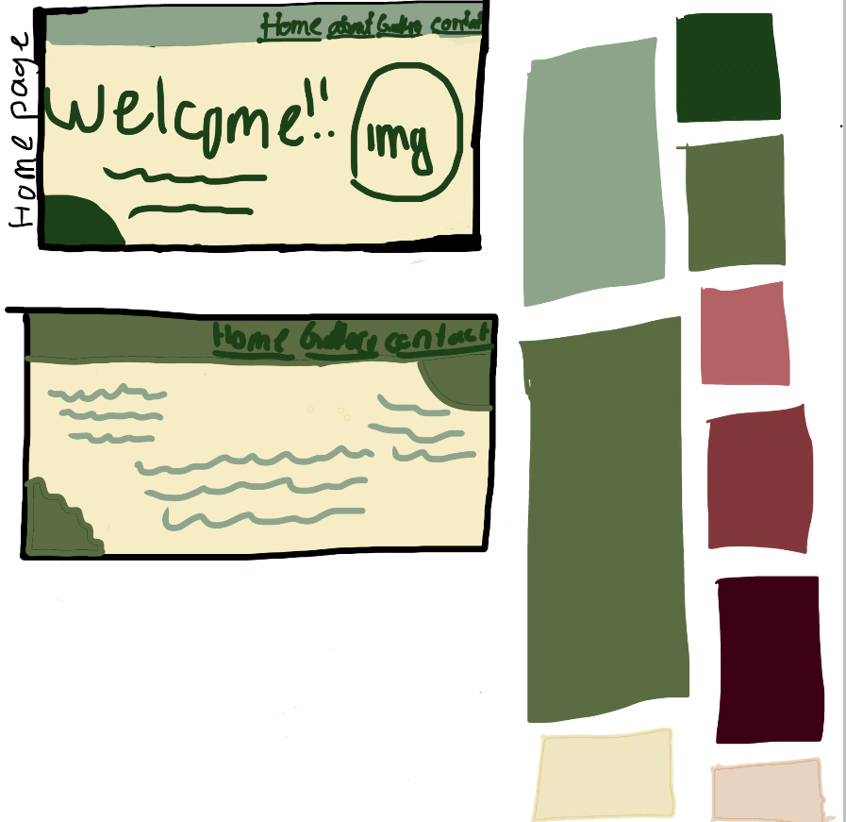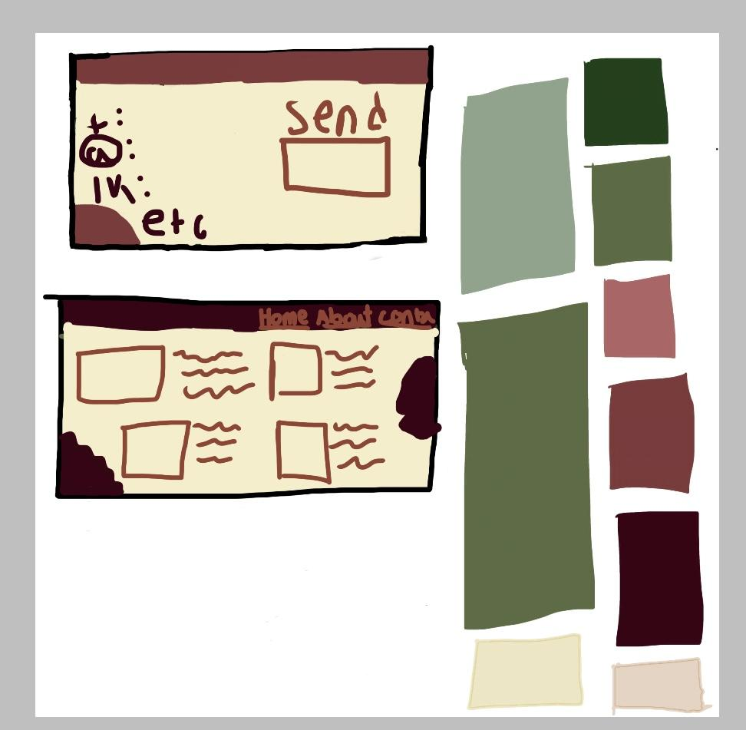

These sketches are the result of 4 different inspiration templates. The color on each page will be one of the colors from the background image. Even though the sketch might not look exciting when looked at, the final product will blow the mind of the audience as it reflects creativity As the theme for this website is specific.

**Colors**:shades of red,pink,green,and beige

**Fonts**:georgia,’time new Roman’,times,serif.

**Text Sizes**: Varying from 5px to 50px.

**Image Placement**: Right,centre, left side of the page.

**Video Details**: Speed-up videos with background music

CRITERION C - Documentation of the Process

Where should I even start? The creation of this website had to be one of the hardest things I've done so far in ICT. From the sketches to the coding, nothing was easy. I struggled a lot. I'm not usually an ‘everything must be perfect’ person, but this project turned me into one, and as someone who is naturally very hesitant and indecisive, even simple tasks like choosing a colour palette, determining the right webpage layout, resizing images, designing text behaviour, styling the containers, and selecting a background image that matched the theme became incredibly challenging. Everything from A-Z was a hustle.

Normally, I don't get easily frustrated, stressed, or angry, but this project managed to stir emotions I myself never knew existed within me. I cried, sweated, rolled on the floor, and at one point, I even considered giving up and accepting failure, for not only was my laptop uncooperative, but power outages, internet issues, the VSC app, HTML and CSS tags, my eyes and practically everything else seemed to conspire against my success.

The coding process was, without a doubt, the most frustrating part of this entire rollercoaster. No matter how hard I tried or how many times I checked for errors, the code simply wouldn't work ,and despite reaching out to multiple people for assistance, no one was able to help/assist me. I felt desperate and defeated. There were moments when I wanted to give up entirely.But I didn’t. I didn’t give up because, more than anything, I wanted to prove to myself that I could do it—that I could bring my silly simple sketches to life without relying solely on machines.and i did it.I transformed my sketches, my ideas, and my vision into reality,and although It wasn’t perfect,it was close to what I had imagined. The best part of all was that I accomplished most of it on my own.

In conclusion, the process of creating this website was a true rollercoaster, but I managed to see it through to the end without throwing in the towel."

CRITERION D

Key Tasks in Criterion D - Evaluating

1.Evaluate the Success of the Solution:

"The final product turned out to be a huge success, despite all the challenges I faced along the way. The website not only meets all the criteria and aligns with the ideas I had envisioned, but it is also both visually appealing and highly functional. The colors and theme perfectly complement the intended minimalist, modern, yet clean aesthetic. The text, images, background, navbar, and other elements came together just as I had hoped. The chosen background fits seamlessly—if not perfectly—with the selected color palette

2.Gather Feedback from Users:

After seeking for Feedback from my peers and family members, here are the changes I decided to make.

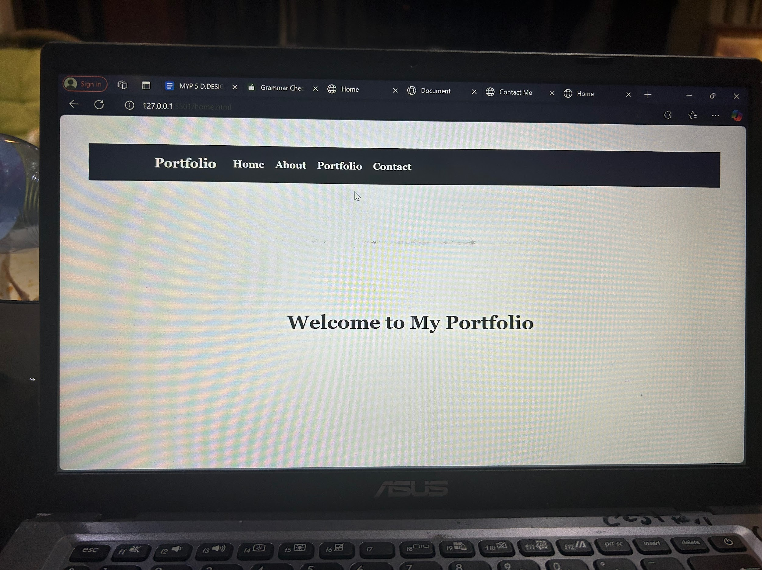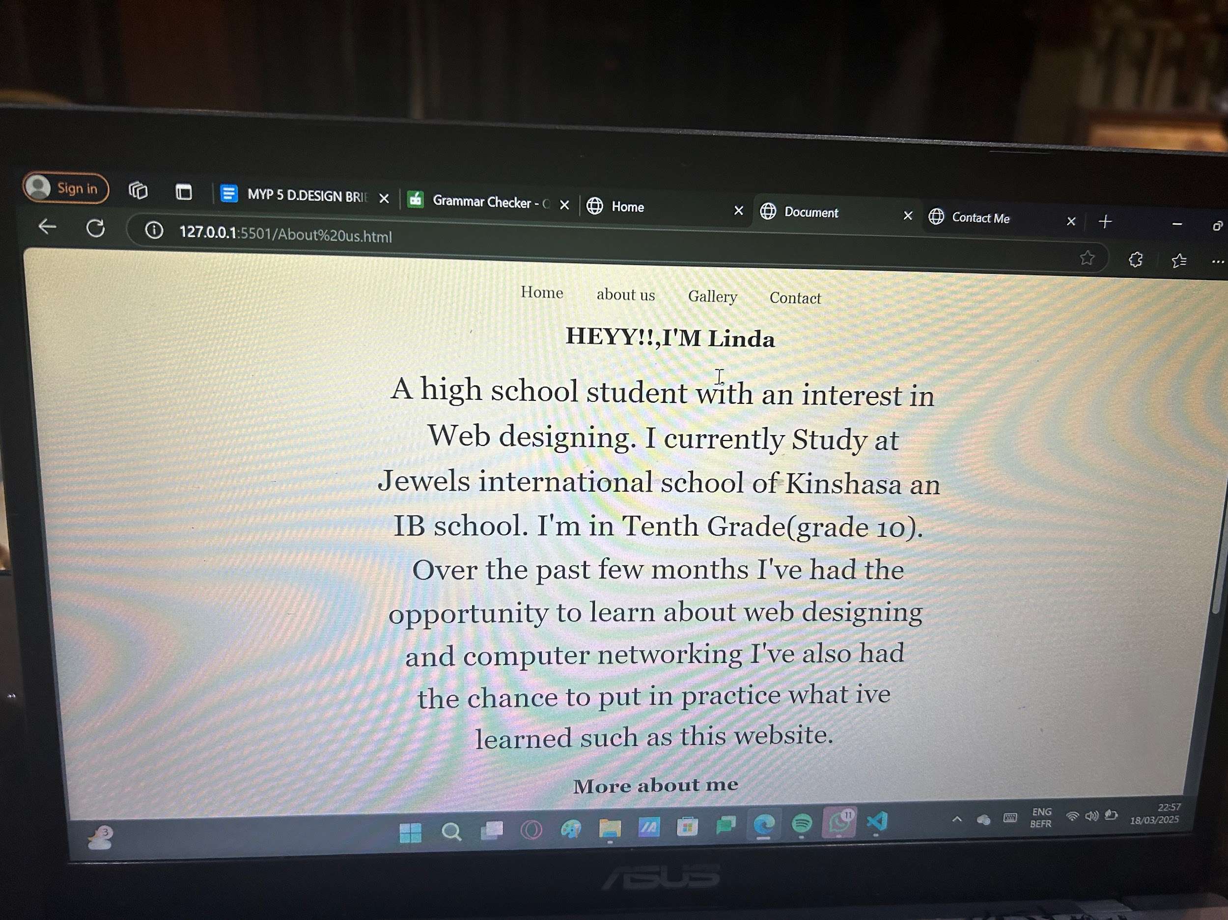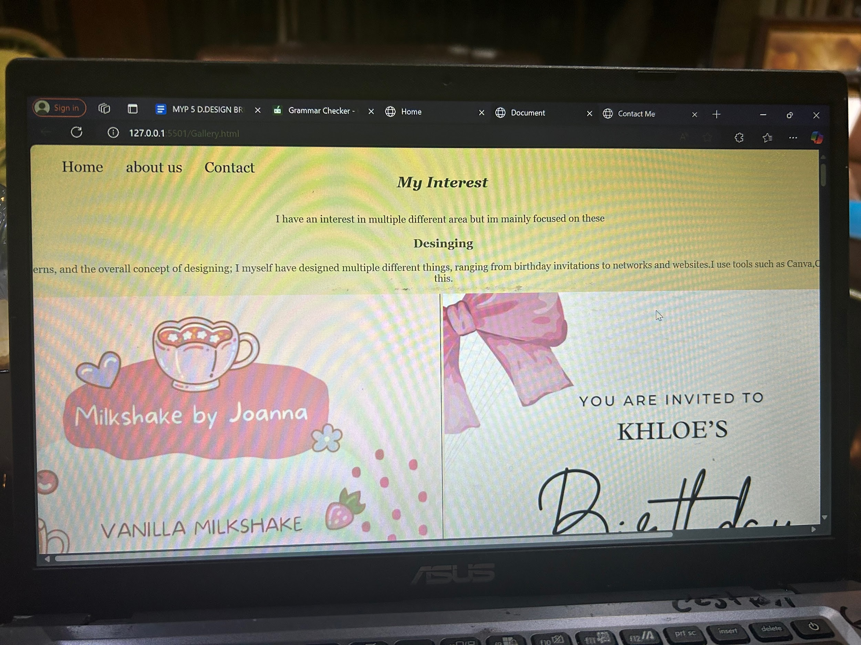this was the website before i took the any feedback in consideration and this is after

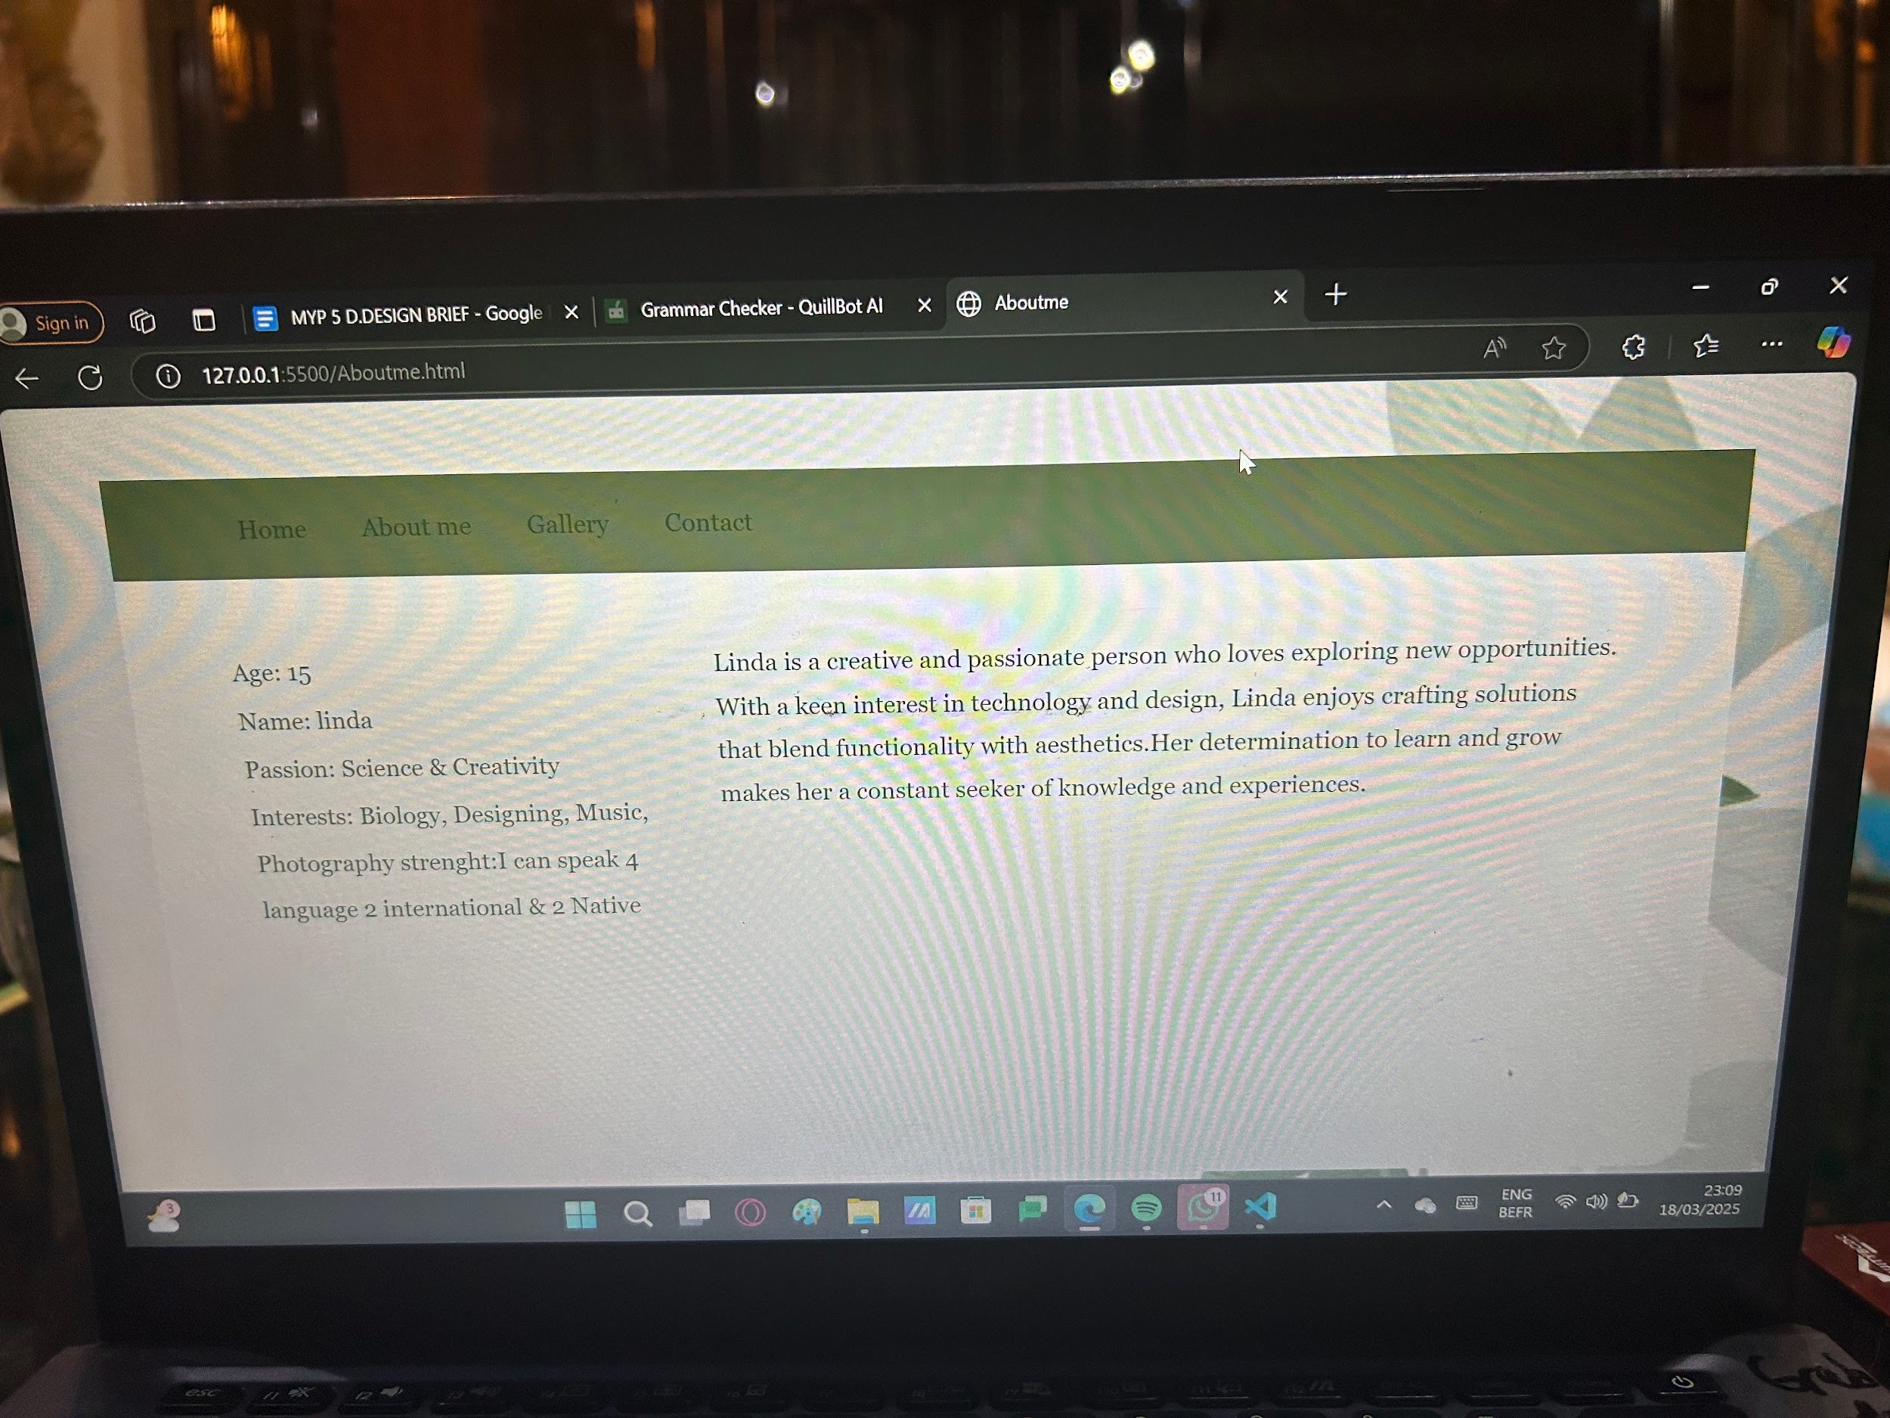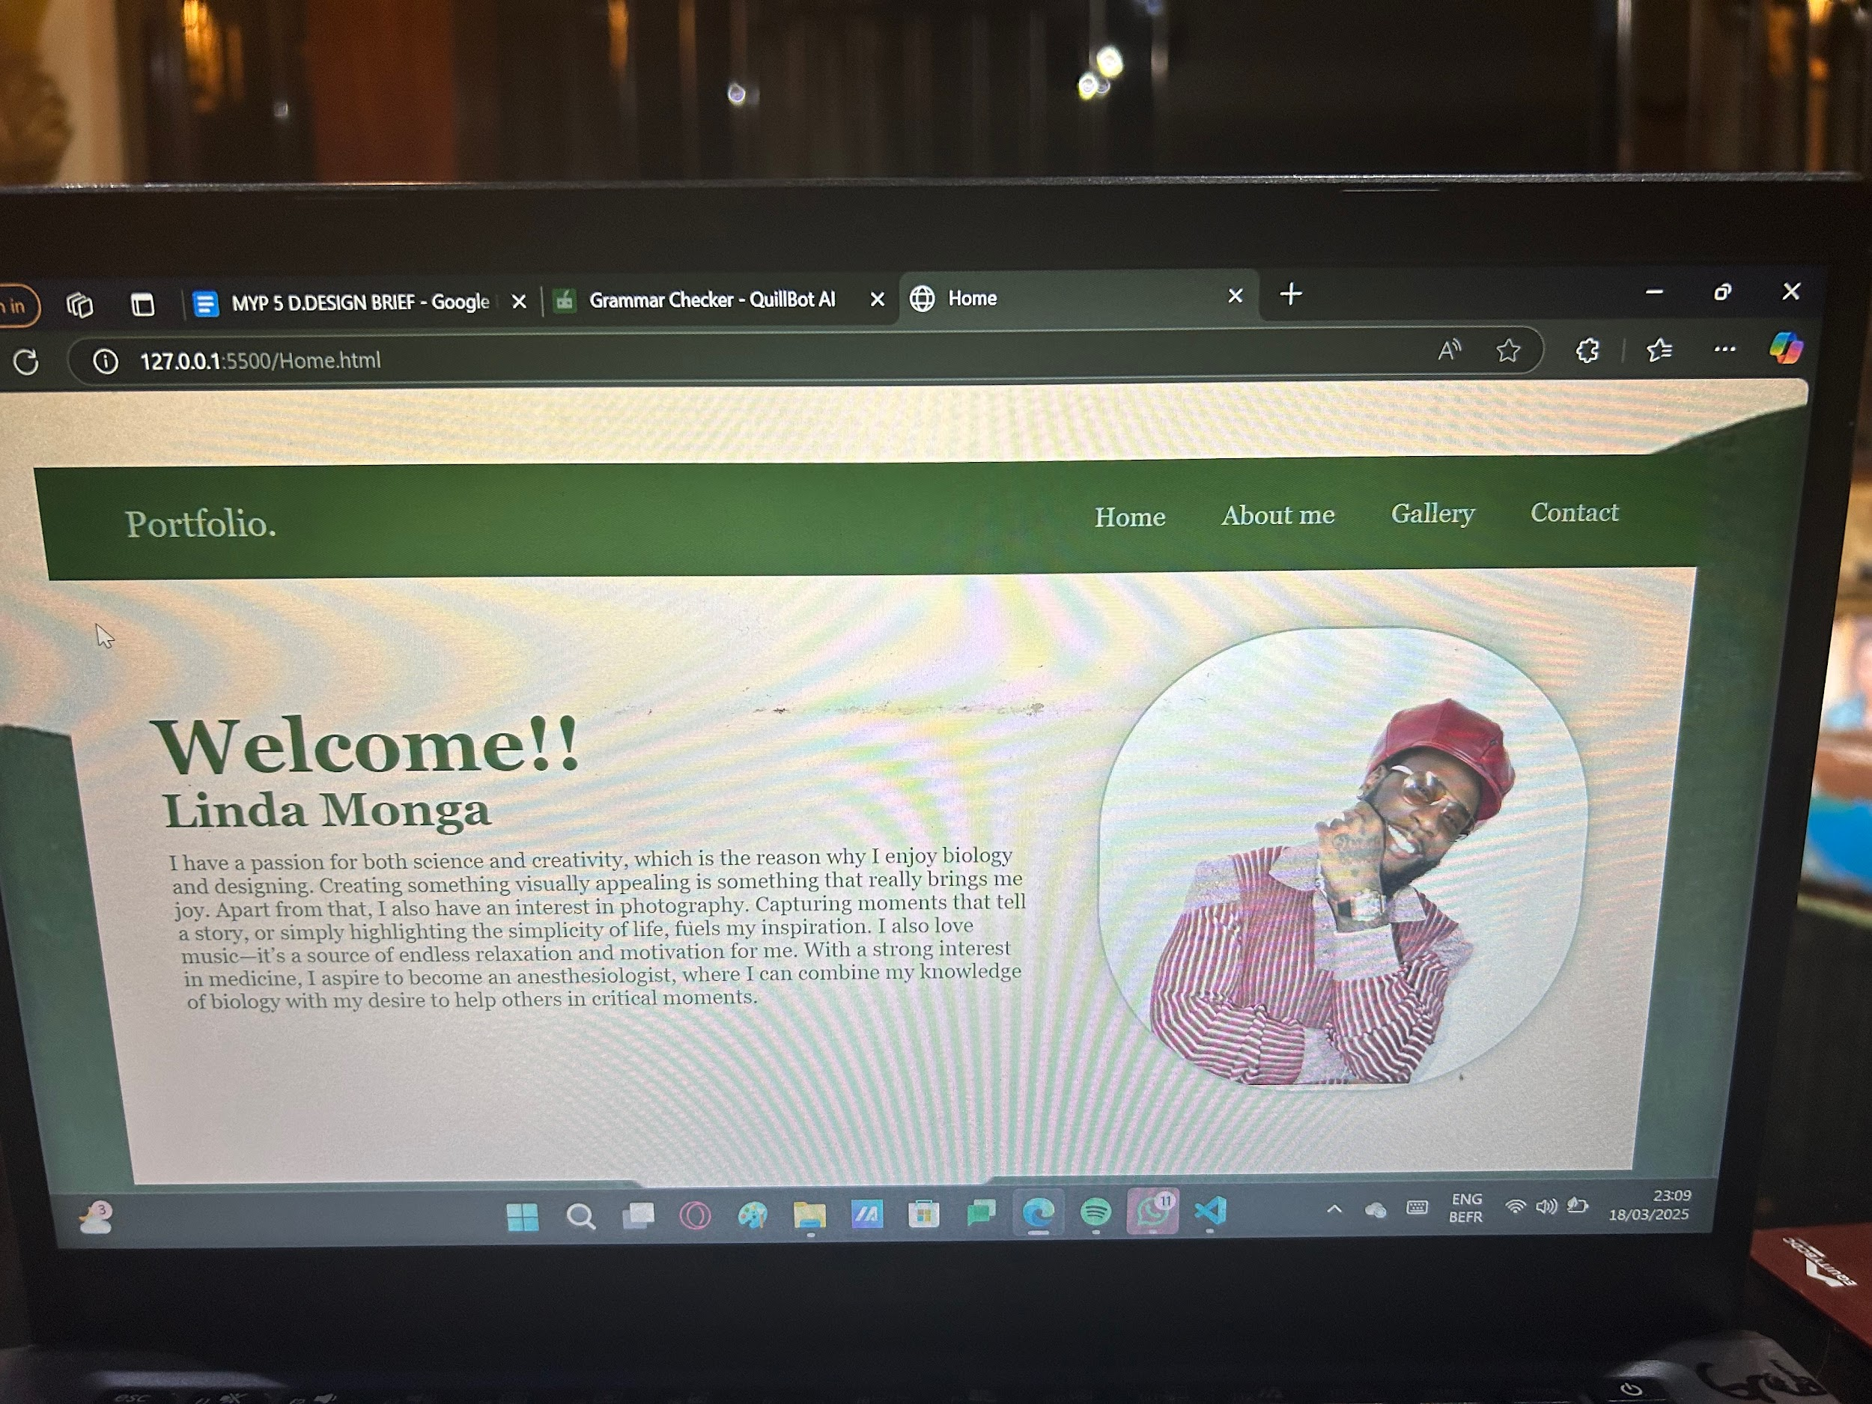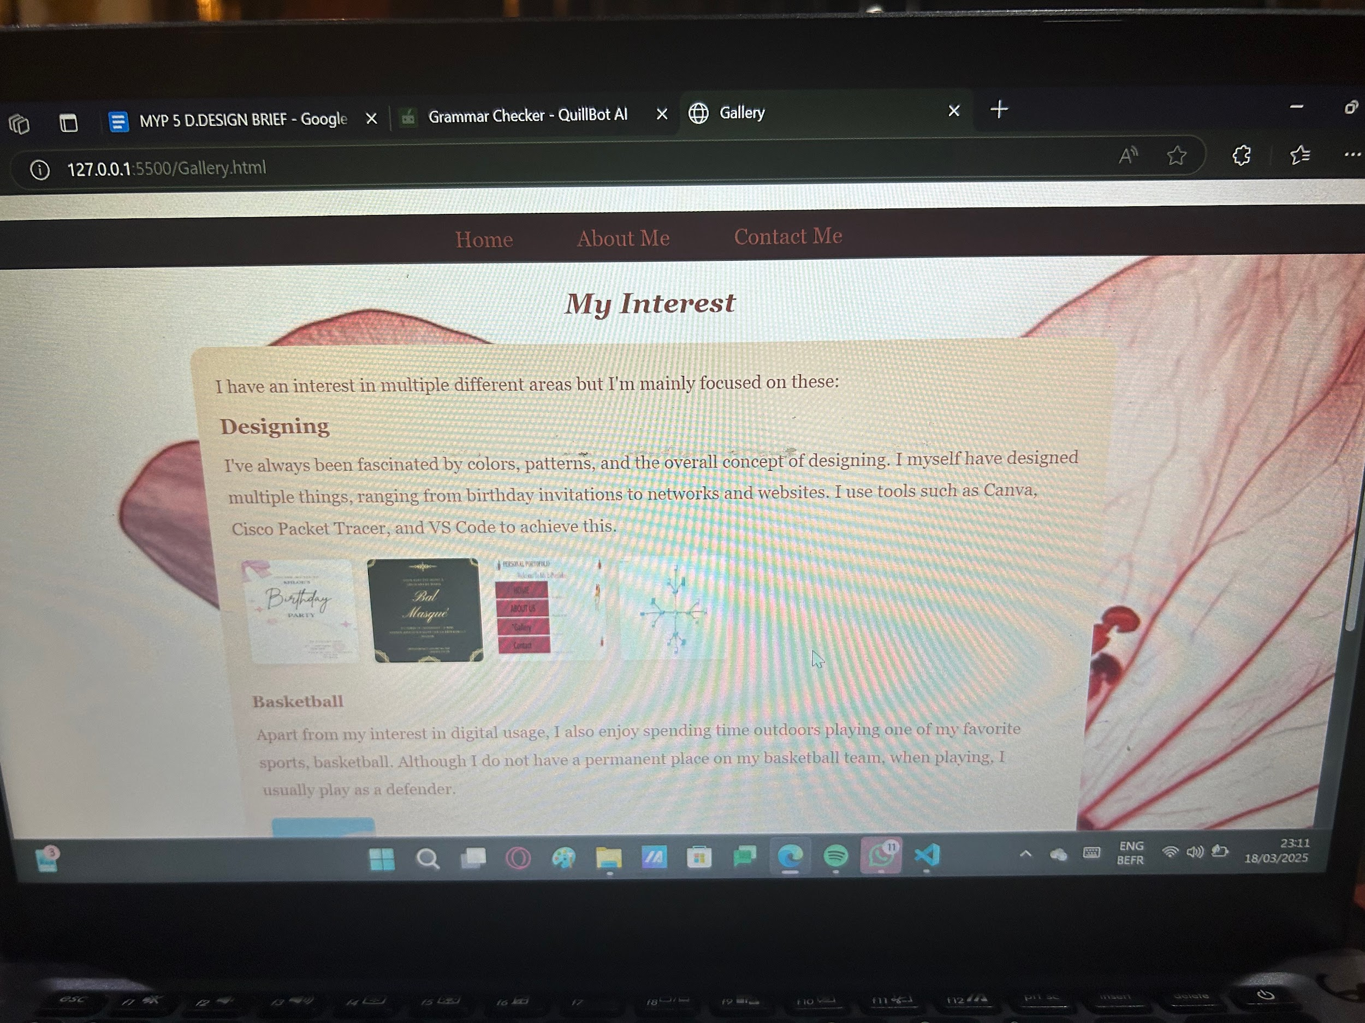

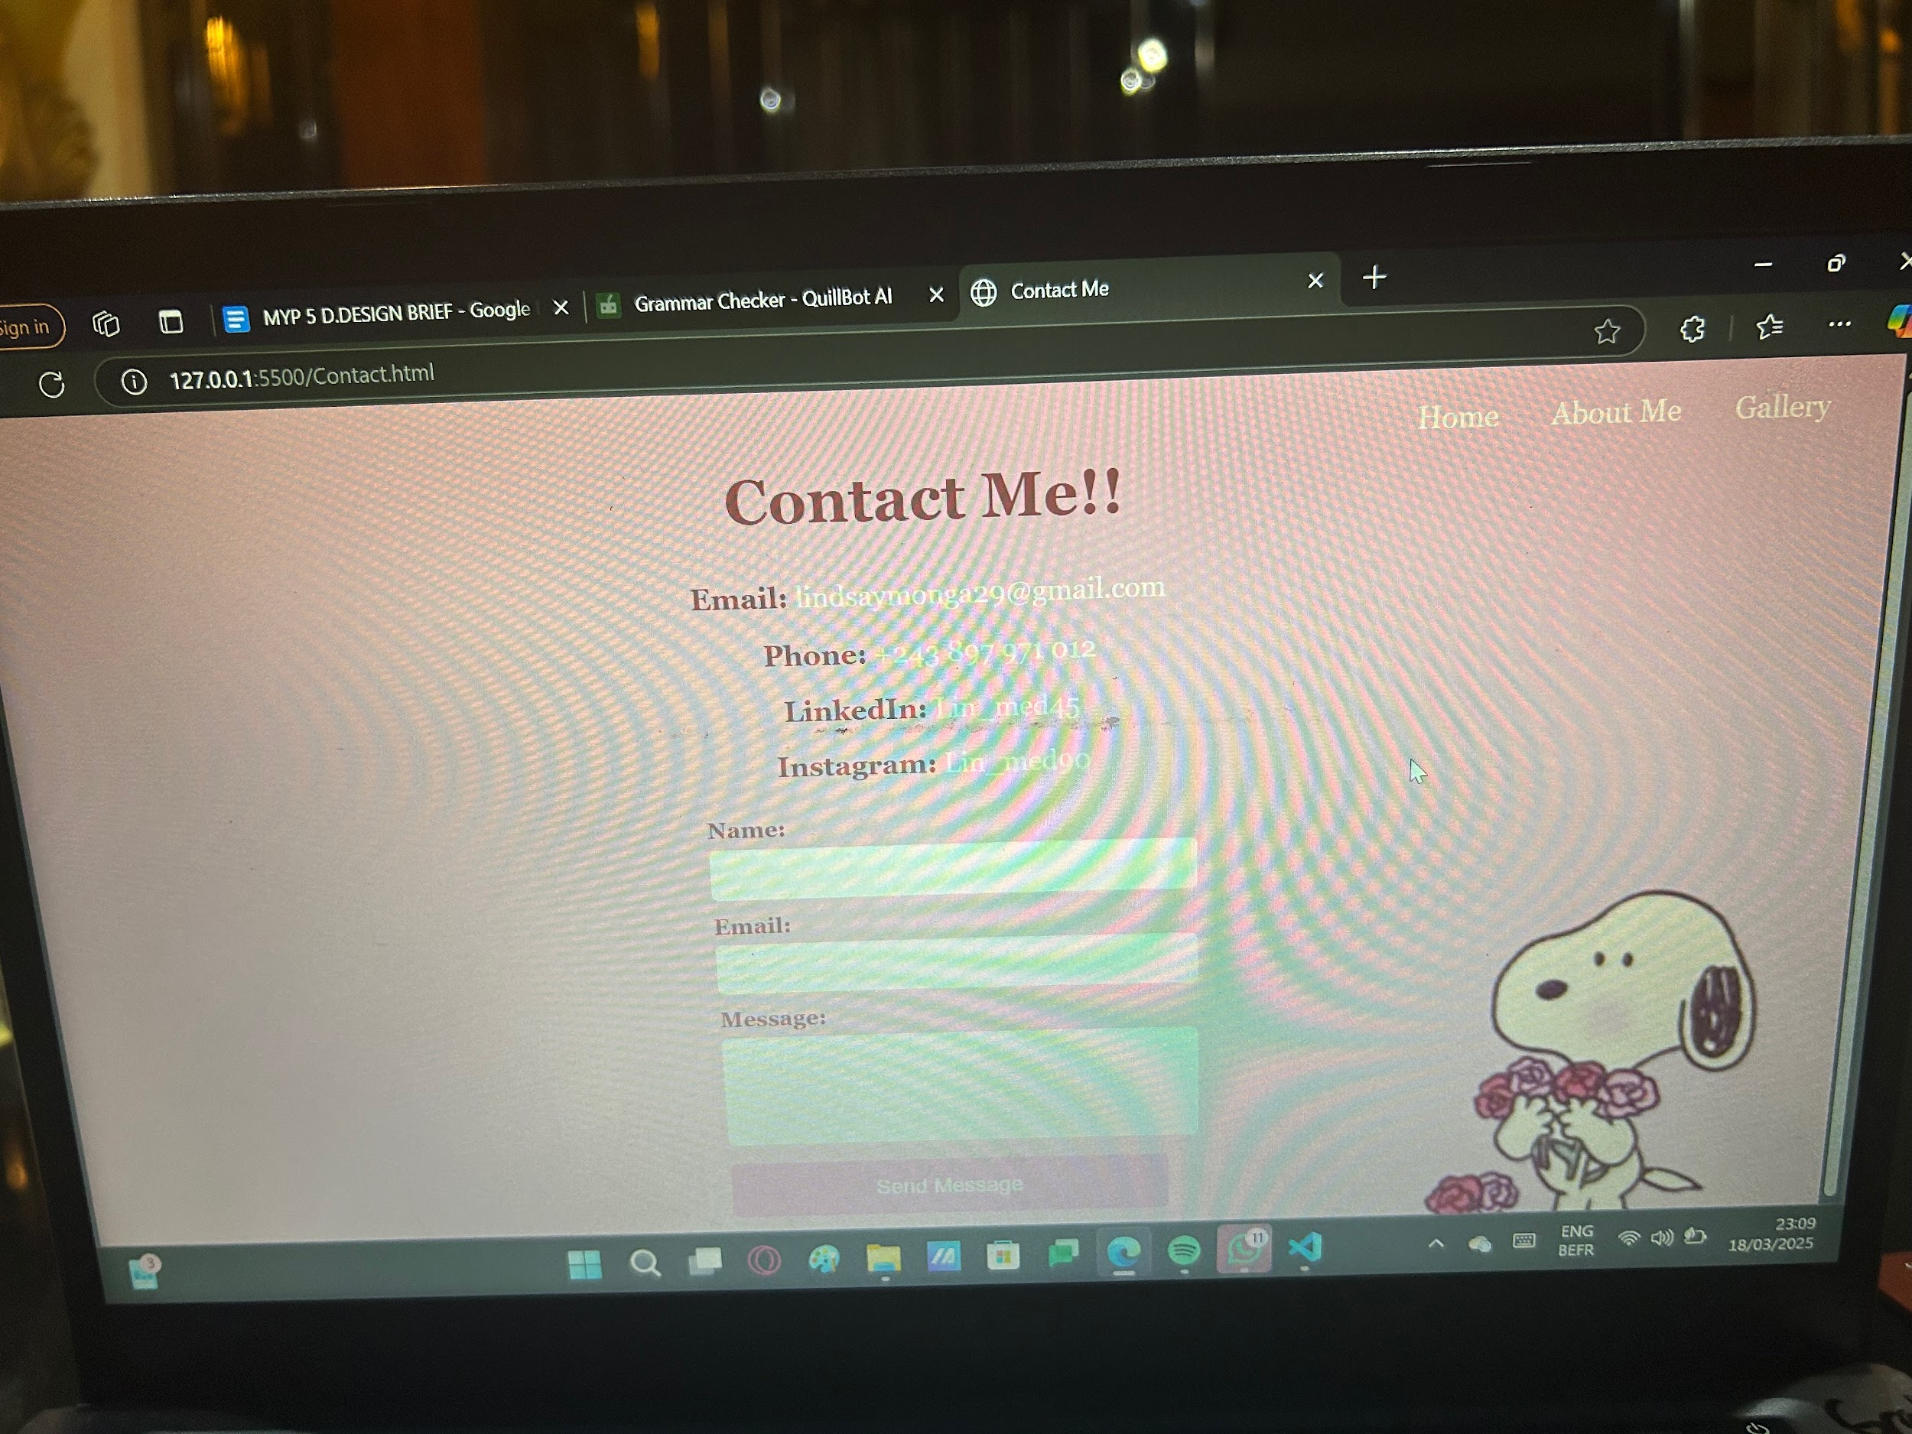

The feedback i got was

Anais (sister) - “Wow, and you did it all by yourself? I’m impressed. It’s beautiful, but you could do better.”

Mary (friend) - “The website isn’t really expressing your creativity, but if you like it, it’s good.”

Hannah (friend) - “The website is too plain. It’s not meeting any of your success criteria; it’s neither visually appealing nor functional. Do better.”

Khloe - “Linda, if you like it, I love it. But do it better.”

Therese (friend) - “It’s not pretty at all. Please change it. Linda, what is this? Do you even have a navbar?””

4. Reflect on the Design Process:

This project was a very engaging experience for me. Even though I had a clear idea of how I wanted my website to look, bringing that idea to life was a challenge in its purest form. The coding really tested my limits, both physically and mentally. It stimulated my creativity and problem-solving skills in ways I never could have imagined. I learned so many new things you could do with CSS that I didn’t know were possible. I managed to memorize complex commands in CSS, such as:

```css

body {

background: url(example.jpg) no-repeat center/cover;

}

```

and a few simple commands like `.nav a:hover`, `<li>`, and `<header>`. The most interesting thing I learned was how to place a background color and a background image at the same time, and how to make elements change color when you interact with them. Although the coding was tricky, I really enjoyed seeing the outcome.

Overall, this project not only turned out to be a success but also allowed me to expand my creativity even further, enhance my typing speed, and improve my thinking skills. I acquired valuable knowledge that will benefit me throughout my life, especially in today’s technology-driven world, where everything is done through screens and the internet.